Hardware
The Echo Yeast temperature-controlled incubation and optical readout module
Influenza arrives every year, and the way we watch for it is arranged almost entirely around people: someone develops a fever or a cough, a swab is taken, the sample goes to a laboratory, and a result comes back later. There is nothing wrong with that chain — it simply starts a little too late. By the time the result exists, the virus may already have made its way through classrooms, wards and waiting halls.
Waiting for someone to run a fever
Influenza A virus (IAV) is a persistent global public-health threat. WHO estimates that seasonal influenza causes around 1 billion infections, 3–5 million cases of severe illness and 290,000–650,000 respiratory deaths each year, with children, older adults and immunocompromised people carrying the heaviest burden. The surface haemagglutinin (HA) protein continually escapes existing population immunity through antigenic drift and shift, so vaccine strains always lag behind circulating strains: the virus keeps changing, while our window on it opens only once symptoms appear.
Starting from symptoms decides what such a chain can and cannot record. A throat swab can only be taken from someone already feverish or coughing; before that point, the particles they exhale are already in the air of the same room. Patient-centred surveillance therefore carries a built-in delay — it records what has happened, and does not announce what is about to.
The half that travels through the air
Bringing air into the picture is what closes that gap. The most direct gain is pre-symptomatic warning: detecting virus in indoor air before large numbers of clinical cases appear gives control measures a head start — ventilation, disinfection and crowd management can be scheduled before infections happen rather than after.
It also puts risk in its proper place. Within one building, classrooms, wards and waiting halls do not carry the same risk, and air monitoring can tell which zones are the hot spots, so that limited effort goes where it is needed. For national influenza networks, built around clinical patients, this adds the environmental dimension that trend assessment currently lacks. And in the settings that carry the heaviest burden — schools and care homes — a real-time air risk assessment bears directly on reducing cluster outbreaks.
Diluted almost to the point of disappearing
Finding virus in air is not primarily a question of whether it can be recognised, but of whether enough sample can be obtained. Viral particles occur at very low concentration in ambient air, and a sampler can process only a limited volume of it; multiply the two and what reaches the liquid is a very small amount indeed.
The accepted paradigm is a two-step workflow: a bioaerosol sampler collects airborne particles on site, and the sample is then sent back to a central laboratory for qRT-PCR. It is sensitive and dependable, but it splits sampling from detection across two places and two moments, with transport and laboratory turnaround in between, so what comes back is usually retrospective data rather than a field result. No mature low-cost option exists for on-site airborne IAV detection — that gap is what we set out to fill.
Choosing what emits the signal
The next question is what should emit the signal. The familiar answer is a chemical reagent: a chromogenic substrate, an antibody, an enzyme label. These are mature and reproducible, but under conditions that here hold at the same time — airborne IAV, on site, low cost, continuous — each of them is constrained in its own way.
Method | Principle | Limitation for on-site monitoring of airborne IAV
Virus isolation | Inoculation into cells or embryonated eggs, observation of cytopathic effect | Typically 3–7 days; requires a BSL-2 laboratory and cell-culture facilities; unsuitable for screening
qRT-PCR / RT-LAMP | Nucleic acid extraction followed by amplification | Highest sensitivity and specificity, but needs extraction, a thermal cycler, cold-chain reagents and trained staff; samples must go back to a central laboratory, so results are retrospective; detecting nucleic acid is not the same as detecting infectious virus
Rapid antigen test (immunochromatography) | Antibody capture of viral antigen with a colour readout | Cheap, fast and field-usable, but typically 2–3 orders of magnitude less sensitive than nucleic acid methods; antibody batches vary and need cold chain; mostly used after symptoms appear
ELISA / immunoassay | Antibody-enzyme colour or fluorescence readout | Quantitative and high-throughput, but needs a plate reader and laboratory conditions; antibody reagents are costly; sensitivity limits still apply
Conventional bioaerosol sampling + laboratory analysis | Sampler collects airborne particles, which are then sent to a laboratory | The accepted paradigm, but sampling and analysis are separated: transport and laboratory turnaround sit between the two steps, there is no on-site readout, and cost per test is high
Set against those four constraints, each method is either not sensitive enough, or tied to a laboratory, or dependent on a cold chain and batch-to-batch comparison. That led us to change how the signal is generated: instead of an added colour reaction or an antibody, we let a living cell report what it has sensed.
Handing the amplification to the cell
The most substantive advantage of using yeast is that recognition and amplification can happen inside one cell. The recognition element is a genetically encoded protein: the anti-HA nanobody is carried on a plasmid and copied along with the cell, so every yeast cell produces its own reagent and no antibody cold chain or batch comparison is needed.
The cell also amplifies the signal. One receptor activated by one antigen is turned, through the GPCR–MAPK cascade, into transcription of a large amount of fluorescent protein from the FUS1 promoter — a level of biological amplification a colour reaction cannot provide. Yeast is a natural match for this route as well: it already possesses a G-protein-coupled receptor → Gα → MAPK pathway, which is precisely the interface an engineered GPCR needs, something a bacterial chassis cannot offer.
The output end is simpler for the same reason: yEGFP is a fluorescent protein the yeast synthesises itself, so no chromogenic substrate has to be added to the sampling liquid and there is no substrate to be diluted or degraded. The chassis is also a reassuring one — BY4741 is a non-pathogenic biosafety-level-1 yeast, and its auxotrophic markers add a further containment barrier, since the engineered strain cannot proliferate stably in a natural environment. There is a further consequence: retargeting means replacing only the nanobody domain, while the heating and optical hardware stays exactly as it is.
The few changes written into the genome
Wild-type yeast, however, neither recognises the HA of human influenza virus nor accepts an engineered GPCR. To turn antigen binding into gene expression, three changes at the genetic level are needed.
The first releases the pathway’s own brake: knocking out FAR1 and SST2 removes the G1 cell-cycle arrest and the negative regulation imposed by the mating pheromone pathway, so that the signal can be sustained and stable.
The second gives the yeast a new interface: building a Gpa1–Gαq chimeric G protein by replacing the five C-terminal residues of yeast Gpa1 (KIGII) with the human Gαq sequence EYNLV, so that the yeast G protein can be recognised and activated by a human-derived receptor and the heterologous receptor is coupled into the yeast MAPK pathway.
The third installs a switch with very low background: assembling the PAGER fusion receptor (MT1 auto-inhibitory peptide – anti-HA nanobody – TEV site – ALFA tag – hM1Dq) translates “HA bound” into “inhibition relieved”, so that the receptor stays closed when no antigen is present and opens only when there is.
None of this can be done with a chemical reagent. An antibody or a chromogenic substrate reports only the instantaneous event of binding or not binding; it cannot convert that event into ongoing gene expression inside a cell, nor be copied and amplified as the cell divides. We are not merely swapping one recognition molecule for another — we hand both recognition and amplification to the same living cell.
We should be explicit about one point: the only small molecule that must be added is the agonist DCZ, which goes into the medium with the yeast before sampling and supplies the activating ligand for the GPCR. Recognition itself is entirely genetically encoded and requires no antibody or enzyme-labelled reagent.
1 What the Hardware Is Worth: Folding the Whole Chain into One Cup
The performance ceiling of a biosensor is set by its molecular design, but whether it can actually be used depends on whether the hardware can fit that chain into a carryable box. We do not treat the hardware as an incubator bolted onto a yeast sensor. Its job is to compress the steps that normally live in a sampler, a sample tube, a transport box and a laboratory instrument into a single cup.
Step | Conventional paradigm (aerosol sampling + laboratory qRT-PCR) | Our hardware
Sampling | A sampler collects airborne particles onto liquid or a filter | The cyclone spins airborne particles straight into the yeast medium in the cup
Sample transfer | Transfer to a tube, labelling, cold-chain transport | Not needed: the sampling cup is the culture cup and the detection cell
Signal generation | Nucleic acid extracted and amplified in a laboratory | Engineered yeast in the cup are induced by the antigen and express the fluorescent protein themselves
Readout | qPCR instrument in a laboratory | 485 nm excitation / 528 nm collection at 90°, converted to an electrical signal on site
Time to result | Hours to 1–2 days including transport and queueing | Sampling and expression overlap; total time on the order of hours
Cost per test | Reagents + instrument amortisation + specialist labour | Medium + disposable structural parts (the yeast amplifies itself)
Retargeting | Redesign primers and probes, revalidate | Replace the nanobody domain only; heating and optics hardware unchanged
- Sampling cup = culture cup = detection cell: the cyclone drives airborne particles straight into the yeast medium inside the cup, so the sample never has to be transferred to another vessel. Transfer loss, transfer contamination and sample mislabelling disappear at the source.
- Readout on site: 485 nm excitation and 528 nm collection at 90°, converted to an electrical signal there and then. This is the most fundamental difference between a field-deployable method and a laboratory method.
- Overlapping in time: the yeast is in the cup from the start, so while sampling proceeds it is simultaneously being induced and simultaneously synthesising fluorescent protein. Sampling time and expression time overlap instead of adding up.
- Integrated over volume and time: the cyclone keeps enriching airborne virus into a limited liquid volume while the yeast keeps accumulating fluorescent protein — low instantaneous concentration is integrated, in both space and time, into a measurable fluorescence intensity.
- A different cost structure: the cost of qRT-PCR lies in reagents, instrument amortisation and specialist labour; ours lies in disposable structural parts, an LED, a photodiode and culture medium — and the "reagent" grows itself.
- Retargeting without touching the hardware: specificity is set by the nanobody, so changing target means changing strain while heating and optics are reused as they are.
One honest caveat: co-culture means the cup is aerated throughout sampling, which can bring foaming, evaporation and contamination, and the liquid surface must be allowed to settle before readout. These are exactly the points our test stage is designed to quantify, and they are listed in the test plan in Section 10.
2 How We Got Here: From Wet-Cyclone Collection to a Cup of Glowing Medium
This hardware began with a concrete observation. While reading up on how airborne bioaerosols are sampled, we came across the wet-cyclone principle: air is spun at high speed inside a chamber, aerosol particles are driven to the wall by centrifugal force, captured by a liquid film on that wall, and end up as liquid in a collection cup. The technique exists in order to collect what is in the air and hand it on for later analysis.
We paused there. If the endpoint of collection is a cup of liquid anyway, why should that liquid only ever be water or buffer? If we replace the collection liquid with medium containing our yeast, sampling and detection can happen in the same cup.
Following that thought, the whole process falls into eight steps:
- The device draws in air, and the cyclone spins airborne particles — including any influenza A virus present — into the liquid in the cup.
- That liquid is our engineered yeast culture, and the yeast cells carry the PAGER fusion receptor on their surface, whose nanobody domain recognises the HA protein on the influenza A virion.
- When HA binds the nanobody, steric hindrance displaces the auto-inhibitory peptide MT1 from the hM1Dq receptor, relieving the receptor's self-inhibition.
- In the presence of the agonist DCZ, which is already in the cup with the yeast before sampling starts, the de-repressed receptor activates the yeast MAPK pathway through the Gpa1–Gαq chimeric G protein, and the FUS1 promoter is switched on.
- FUS1 drives transcription of yEGFP, and the yeast begins to synthesise green fluorescent protein.
- We shine 485 nm excitation light into the sampling cup, exciting the fluorescent protein that has already been expressed.
- The fluorescent protein emits at 528 nm, collected by a receiver placed at 90° in space to the excitation path.
- The receiver converts the optical signal into an electrical signal, and from that signal we judge whether influenza A virus is present in this air sample.
The 90° angle is not arbitrary. The excitation beam is strong and the fluorescence is weak, and their centre wavelengths differ by only about 43 nm. If the receiver sat on the same axis as the emitter, scattered excitation light would simply swamp the fluorescence. Turning it 90° takes the main excitation beam out of the receiver's direction, and two narrow-band filters then separate that 43 nm properly.
One more point is worth stating. DCZ sits in the same liquid as the yeast from before sampling begins, so the switch of this system is in practice thrown by HA alone: without HA the receptor stays self-inhibited and the pathway is closed, and only when HA is present is that inhibition relieved. DCZ effectively presets the switch to a state in which it can be opened, and the discriminating signal comes from the antigen itself.
The hardware therefore falls into three blocks, each matching one stretch of that flow: the heated block keeps the yeast at its optimum 30 °C; the detachable optical plugs provide the 485 nm excitation and 528 nm collection paths; and the signal-acquisition circuit turns the nanoampere-to-microampere photocurrent from the photodiode into a number we can act on.
[Editor's note] This section describes only the publicly documented principle of wet-cyclone collection. No specific sampling instrument is named, and no image or material belonging to one is used. A source can be cited here once the relevant permission is obtained.
3 Design Goals and Constraints
- Temperature: yeast protein expression and signalling are temperature sensitive, and drift directly changes the amplitude of the fluorescence signal. Control accuracy is therefore specified as ±0.5 °C with a set point of 30 °C.
- Optics: yEGFP excites at about 485 nm and emits at about 528 nm, only ~43 nm apart. Narrow-band filters (30 nm FWHM, OD3) are required to separate excitation from emission, and the excitation and collection axes are placed at 90° to suppress direct excitation breakthrough geometrically.
- Sample volume: ≥ 1.5 mL at the cuvette stage; at the collection-cup stage the cup is pre-filled with 20 mL of medium containing the yeast, which brings the liquid level just above the junction between the cone and the cylinder.
- Light sealing: we measure microampere-level photocurrent from a photodiode, and ambient light is the dominant noise source. Light sealing is therefore a structural requirement rather than an accessory.
- Serviceability: optical components and the vessel must come apart, be replaceable and be cleanable — this is exactly why the emitter and receiver are plug-in parts.
- Fabrication: with no precision machining available at first, FDM 3D printing is used for fit and assembly checks, and CNC machining is used for the formal test parts.
4 Design Iterations
4.1 The collection cup: from AutoCAD to SolidWorks
14 September — the first collection cup was drawn in AutoCAD: long overall (about 136 mm) with a skirt at the base acting as a support (Fig. 1), so the cup could stand on its own.
21 September — the first 3D model was built in SolidWorks: the supporting skirt was removed, the conical section shortened and the bottom cone radius increased for a smoother shape (Figs. 2–3).
22 September — the second version added optical windows on the conical face (Figs. 4–6). The reason is practical: the cyclone collects only a small volume, so the liquid level sits low. Windows on the cylindrical section would be above the liquid and the optical path would be empty; on the cone they stay submerged even with a small volume. In the current filling scheme the cup is pre-filled with 20 mL of medium containing the yeast, which brings the level just above the cone-to-cylinder junction; because the windows sit on the cone, they keep a margin of immersion even if the level falls through evaporation or sampling.
4.2 The heated block
25 September — the heated block was modelled with a cavity sized to the collection cup and optical channels reserved for detection (Figs. 7–8).
4 October — the optical channel was revised to meet real hardware needs: widened to 8 mm, with the filters, lenses, LED and photodiode all made detachable; EH2.0 was finalised and printed (Figs. 13–16). The original channel was too narrow for the components and left no room for filters; 8 mm accommodates Ø10 mm filters and lens assemblies while still leaving alignment margin.
4.3 Detachable plugs: emitter, receiver and heater
The emitter and receiver ends were drawn on 4 October (Figs. 17–18), and Emitter_Plug, Receiver_Plug and Heater_Plug were completed on 9 October (Figs. 21–26).
These three plugs are not ad-hoc parts for a single test but purpose-designed structures for the project: the emitter holds the 485 nm LED, the focusing lens and the excitation filter; the receiver holds the emission filter, the focusing lens and the BPW34 photodiode; the heater plug routes the heating-film leads and the PT100 into the block while keeping light out and assembly simple.
For the test stage we replaced the in-house collection cup with a standard cuvette and redesigned the heated block around it. A cuvette is a standard part with consistent dimensions and flat optical faces, which lets us validate temperature control and the optical path before the custom parts are finalised. The plug-to-block interface is identical across revisions, so switching back to our own collection cup requires no redesign of the plugs.
4.4 3D printing and assembly checks
The first cup was printed on 30 September and came out poorly because of print settings and our inexperience (Figs. 9–10). On 2 October the hardware module was printed for the first time — supports still inside the optical channel — and the cup was assembled with the heated block to confirm the dimensions (Figs. 11–12). This was the first time our 3D models became physical parts, and the assembly fitted. EH2.0 was printed on 4 October and re-checked with the cup (Figs. 15–16).
4.5 Electronics
The first circuit was designed on 4 October (Fig. 19); soldering began on 5 October with the aim of finishing the wiring around the 10th and running the first test (Fig. 20); the wiring was rearranged on 11 October to keep every component within its safe operating range (Fig. 27).
The circuit is organised by function: power (24 V input stepped down by an LM2596), temperature control (PT100 + MAX31865 + IRF520 + heating film), LED drive (constant-current board + 485 nm LED), signal (BPW34 + OPA350 transimpedance amplifier + ADS1115) and indication.
5 Hardware Log
This section records, date by date, how the hardware moved from drawings to physical parts. Starting from the first time we opened AutoCAD on 14 September, we kept a photograph and a written note every time a design changed, every time something was printed and every time parts were assembled. That was not only for the record: how two parts fit together only becomes clear once you hold them, and the photograph plus that day's note are the only things that let you reconstruct the reasoning a few days later.
The ten milestones below form the skeleton of that work; the day-by-day entries and figures follow.
Date | Milestone | Output
14 September | First collection cup in AutoCAD (with supporting skirt) | Drawing1.dwg
21 September | First 3D model in SolidWorks (skirt removed, cone shortened, bottom cone radius increased) | 收集杯.SLDPRT
22 September | Second collection-cup version (optical windows added on the conical face) | 收集杯2.SLDPRT
25 September | Heated block modelled (vessel cavity + optical channels) | —
30 September | First 3D print of the cup (poor print quality) | —
2 October | First complete print of the hardware module and dimensional check by assembly | —
4 October | Optical channel widened to 8 mm; filters, lenses, LED and photodiode made detachable; EH2.0 finalised and printed; emitter and receiver drawn; first circuit design completed | EH 2.0 10.3.SLDPRT, 激发端 10.3.SLDPRT, 检测端 10.4.SLDPRT
5 October | Soldering started, beginning with the power section | —
9 October | Three plug-in parts finalised | Emitter_Plug, Receiver_Plug, Heater_Plug
11 October | Circuit rewired, power and signal runs separated | —
One pattern repeats throughout the log: design, print, assemble, find a problem, redesign. The 8 mm optical channel, the interface that stays identical between the plugs and the block, and the decision to make the filters and lenses detachable were none of them thought up in one go — each was worked out by going round that loop. This was also the first time the team turned 3D models into physical parts, and the first time optics, temperature control and electronics shared the same bench.
14 September — First collection cup drawn in AutoCAD
This is where the hardware work started. The first collection cup was drawn in AutoCAD: long overall (about 136 mm) with a skirt at the base acting as a support, so that the cup could stand on its own while being placed, carried and aligned during assembly. This version only addressed one question — whether the shape could hold liquid; optics and heating were not yet considered. Output file: Drawing1.dwg.
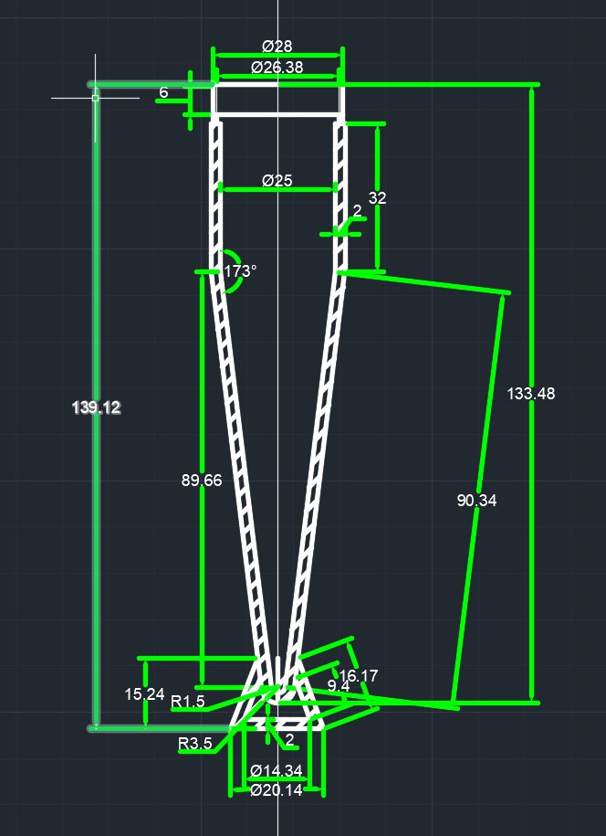
Figure 1. First collection-cup design drawn in AutoCAD, with a supporting skirt at the base
21 September — First 3D model in SolidWorks
Moving the 2D drawing into SolidWorks was the first time we saw the part in real volume and proportion. The supporting skirt was removed, the conical section shortened and the bottom cone radius increased, giving a smoother overall shape closer to the streamline form that cyclone collection requires. Output file: 收集杯.SLDPRT.
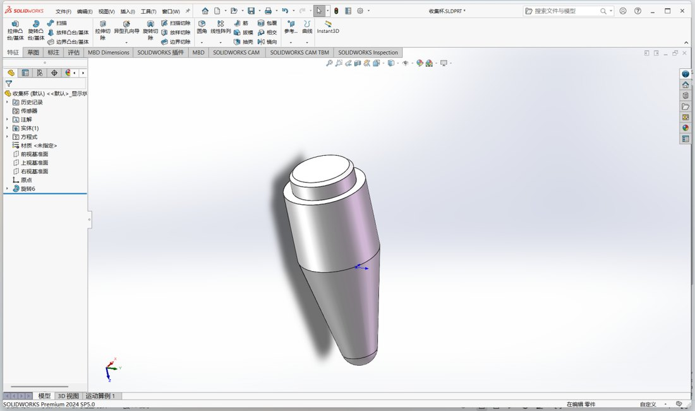
Figure 2. The first 3D collection-cup model, built in SolidWorks
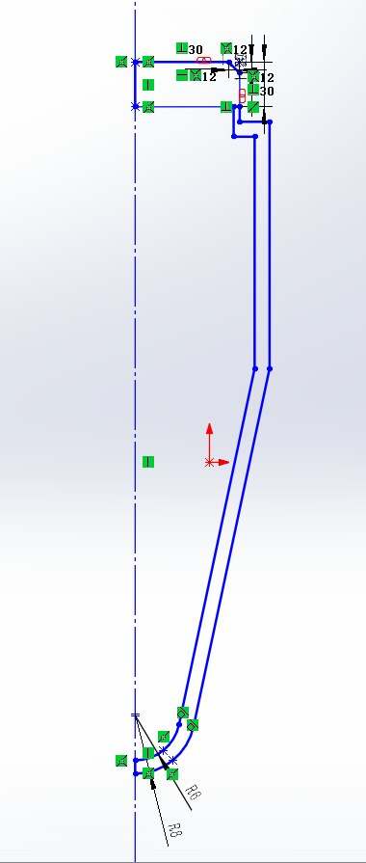
Figure 3. Profile sketch of the first collection-cup version
22 September — Second collection-cup version
The first version was reviewed again for practicality and reliability, and optical windows were added on the conical face. The reason came from the actual working conditions: the cyclone collects only a small volume, so the liquid level sits low. Windows on the cylindrical section would have been above the liquid and the optical path would have been empty; moved down onto the cone, they stay submerged even with a small volume. In the current filling scheme the cup is pre-filled with 20 mL of medium containing the yeast, which brings the level just above the cone-to-cylinder junction, so windows on the cone keep a margin of immersion. Output file: 收集杯2.SLDPRT.
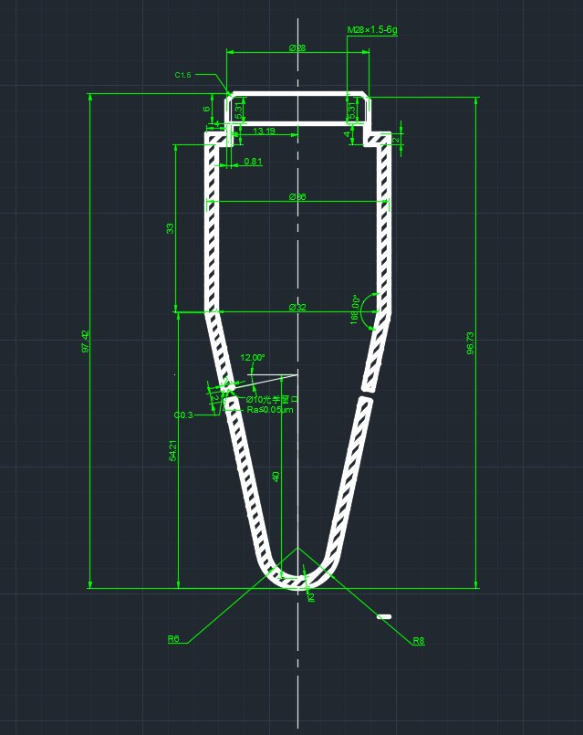
Figure 4. Dimensioned drawing of the second collection-cup version, with optical windows added on the conical face
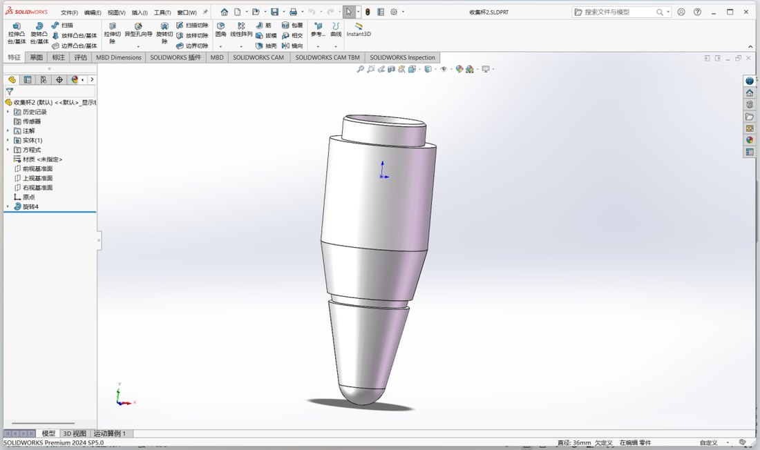
Figure 5. 3D model of the second collection-cup version
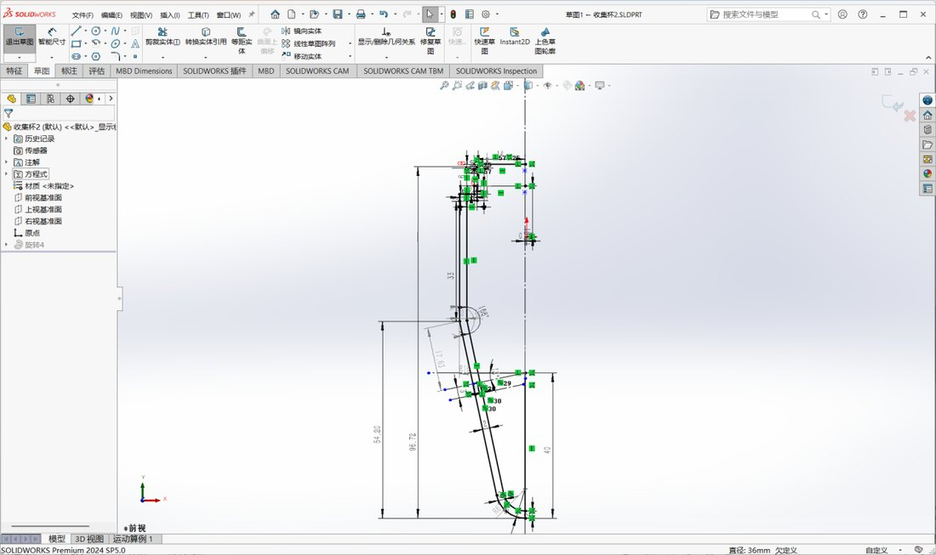
Figure 6. Sketch of the second version, showing the position of the optical windows
25 September — Heated block modelled
A cavity sized to the actual cup was reserved in the heated block, together with optical channels so that excitation light and fluorescence can pass in and out through the block. This was the first time the vessel and the optical path were designed inside a single part.
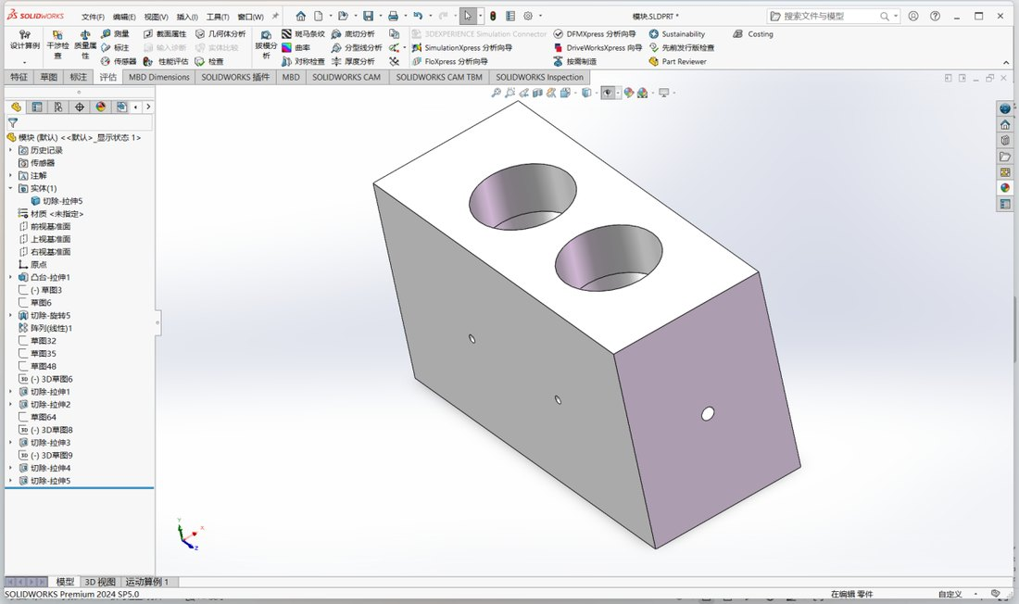
Figure 7. 3D model of the heated block, with the vessel cavity and optical channels reserved
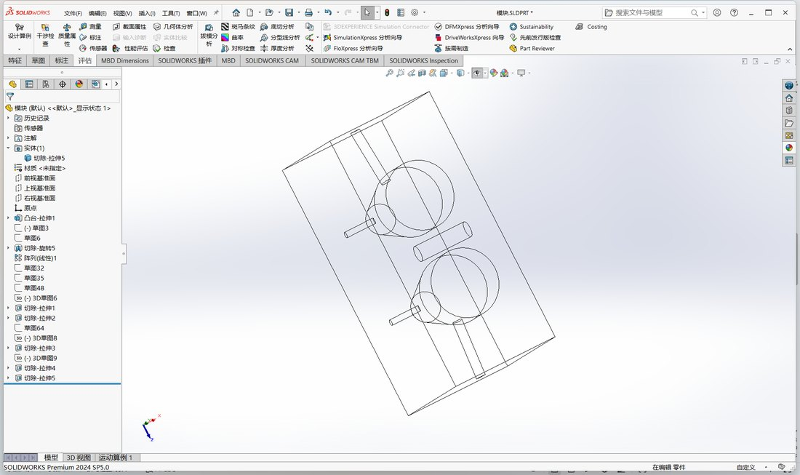
Figure 8. 2D layout drawing of the heated block
30 September — First print of the collection cup
The cup was sent to the printer for the first time and came out poorly because of print settings and our inexperience: stringing on the surface and poorly defined detail. The failure taught us that print orientation and support placement have to be planned at the design stage, and that long slender cones string particularly badly. We recorded the problem and adjusted the orientation and print parameters in the following versions.
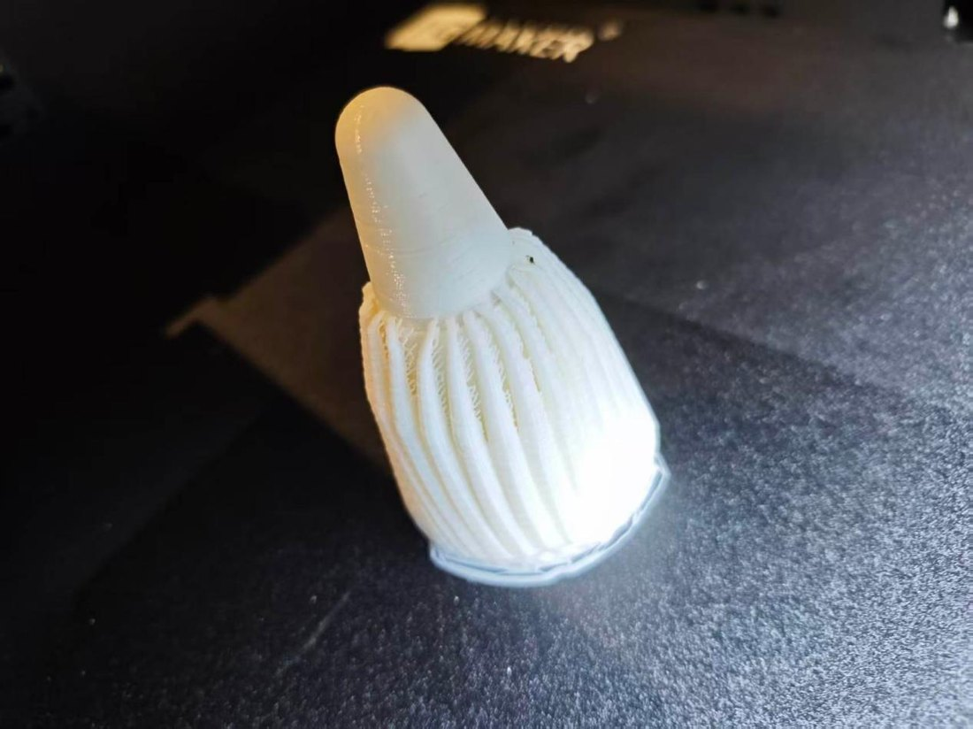
Figure 9. The first 3D-printed collection cup; print quality was poor
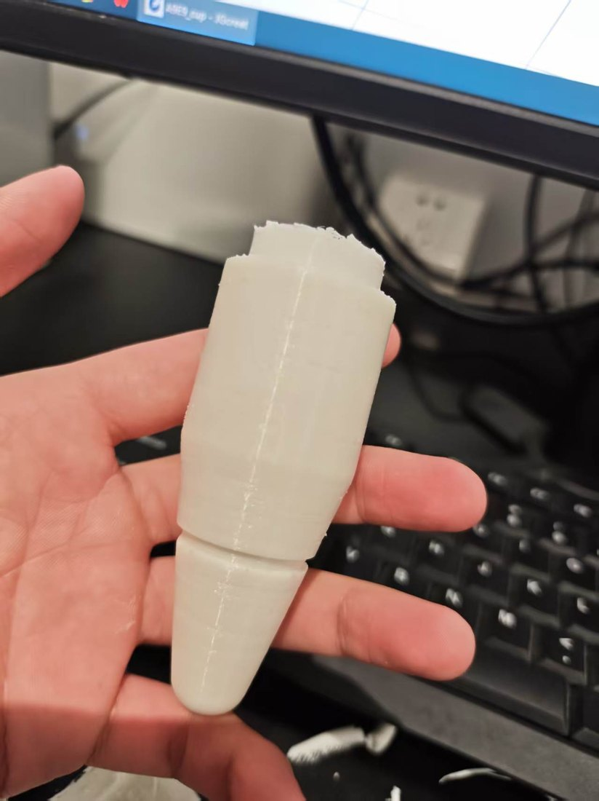
Figure 10. The first printed cup, held for scale
2 October — First complete print and assembly
The entire hardware module was printed for the first time (the supports were still inside the optical channel) and the cup was assembled with the heated block to confirm the dimensions. This was the first time our 3D models became physical parts, and the assembly fitted: the cup-to-cavity clearance and the alignment between the optical channels and the windows were both within expectation.
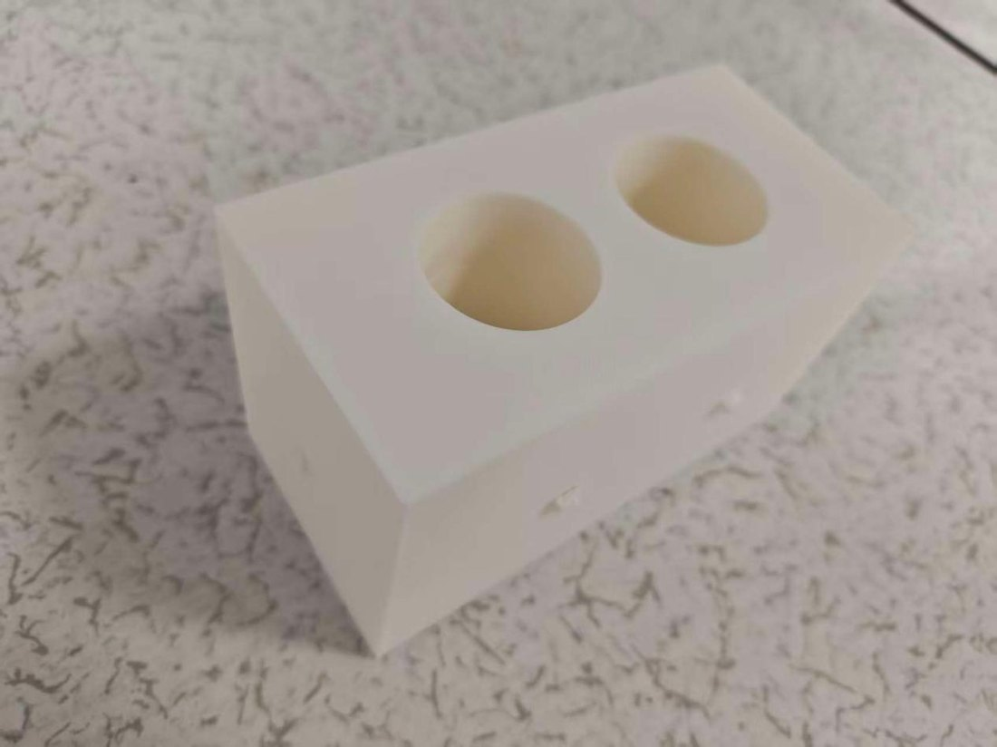
Figure 11. The first complete printed hardware module, with supports still inside the optical channel
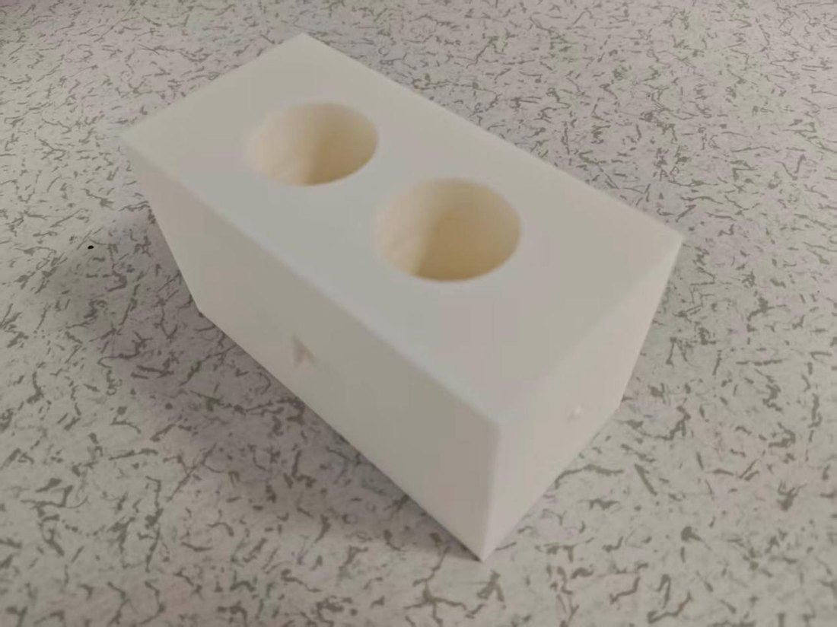
Figure 12. Assembly check of the collection cup and the heated block
4 October — Optical channel revised, EH2.0 finalised, emitter and receiver designed
The busiest day of the build. Following the actual hardware requirements we revised the optical channel, widening the bore to 8 mm and turning the filters, lenses, LED and photodiode into detachable parts. The original channel was too narrow for the components and left no room for filters; 8 mm accommodates Ø10 mm filters and lens assemblies while still leaving alignment margin. EH2.0 was finalised and printed the same day, the emitter and receiver ends were drawn, and the first version of the circuit was completed. Output files: EH 2.0 10.3.SLDPRT, 激发端 10.3.SLDPRT, 检测端 10.4.SLDPRT.
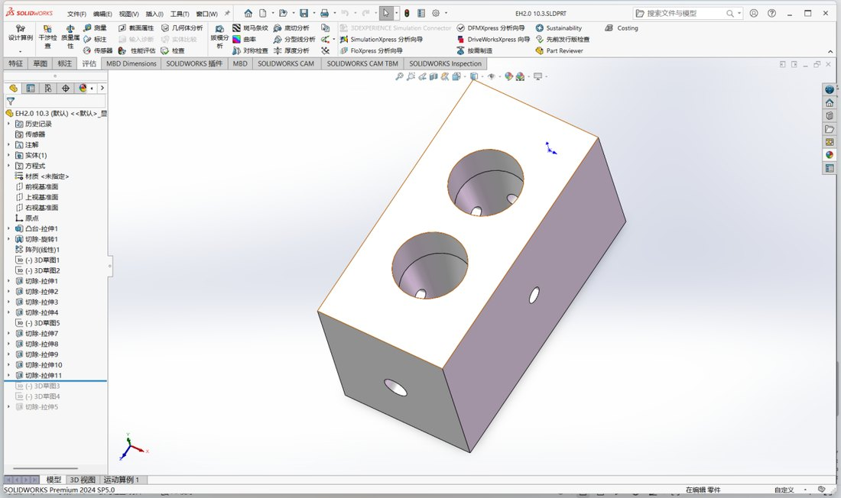
Figure 13. The revised EH2.0 heated block, with the optical channel widened to 8 mm
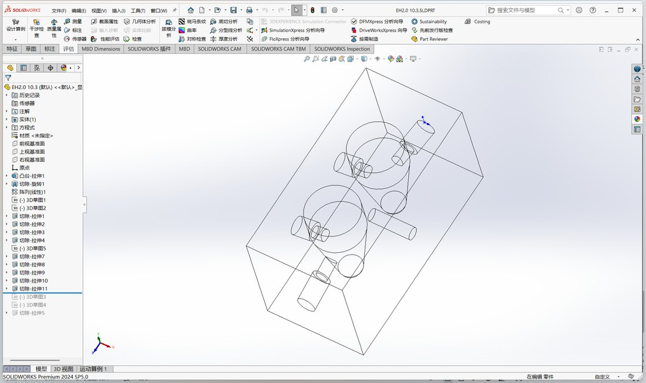
Figure 14. 2D layout of EH2.0, showing the optical channels and the plug interfaces
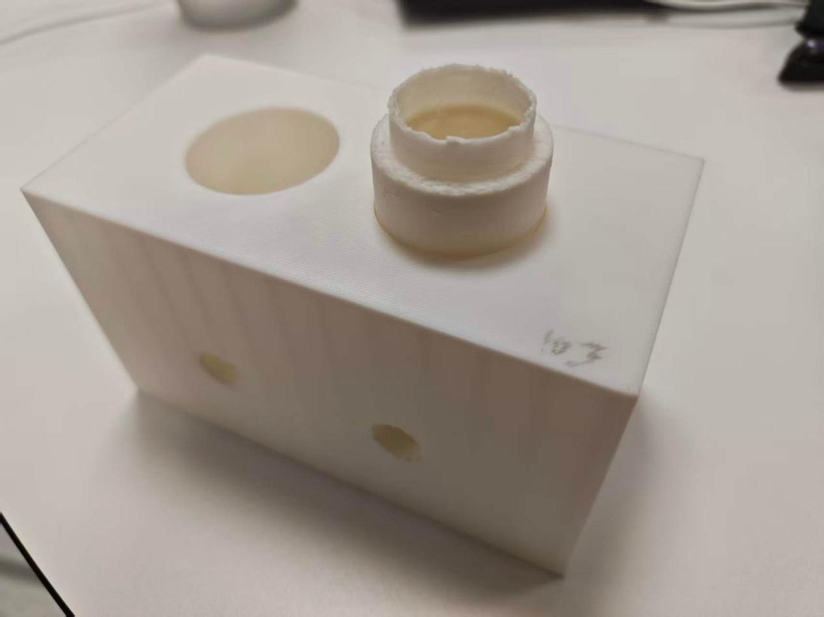
Figure 15. The printed EH2.0 block
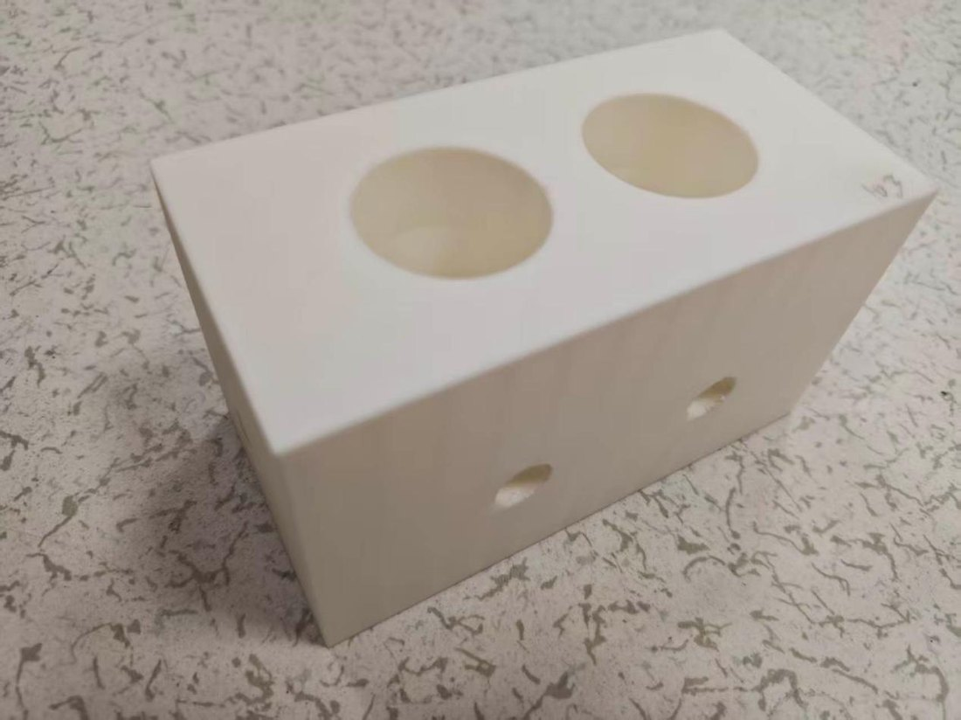
Figure 16. Re-checking the fit between EH2.0 and the collection cup
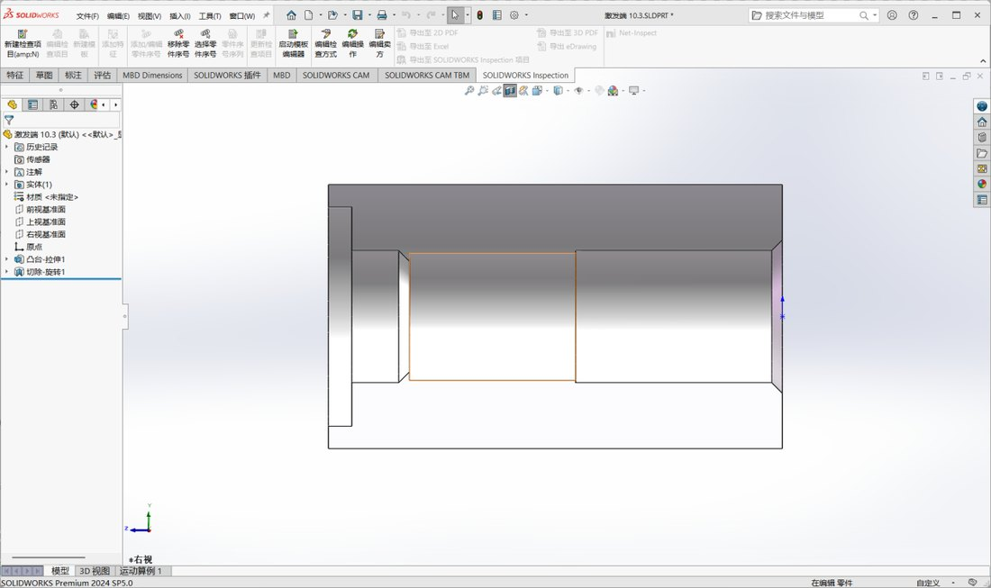
Figure 17. Internal layout sketch of the emitter end
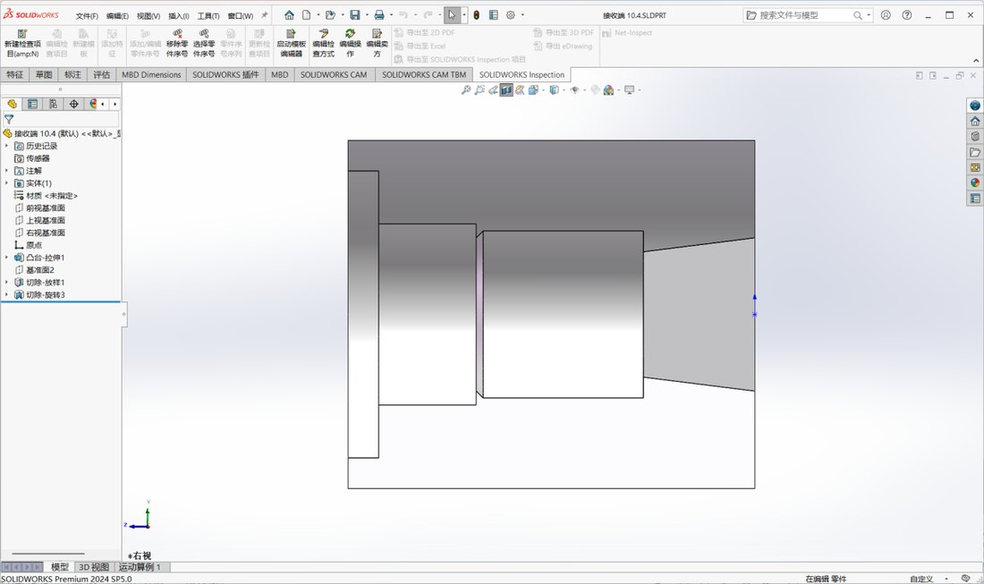
Figure 18. Internal layout sketch of the receiver end
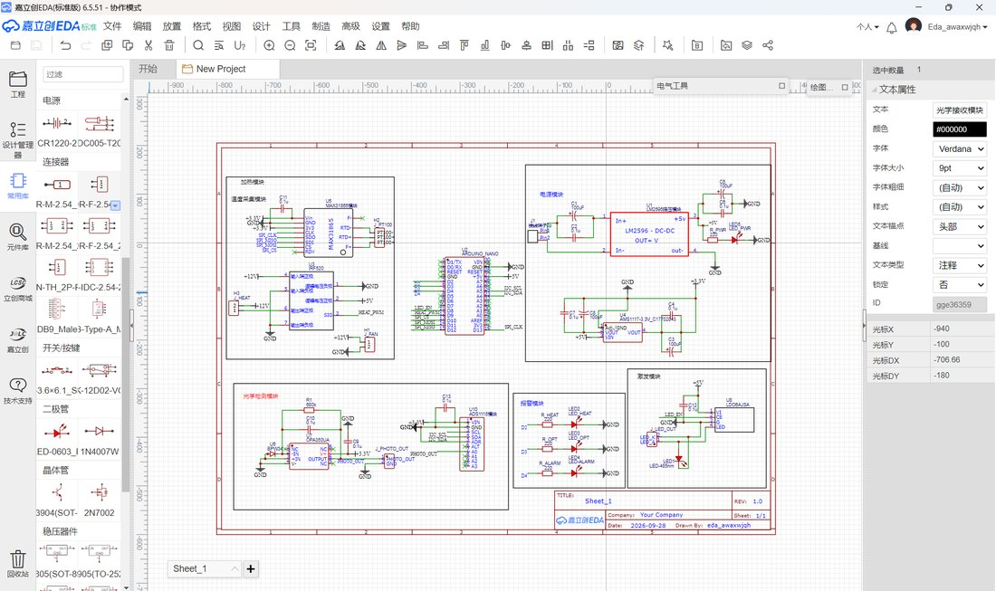
Figure 19. First version of the circuit design
5 October — Soldering started
Soldering began, with the aim of finishing the wiring around the 10th and running the first test. We started from the power section — 24 V input, LM2596 step-down, indicator LEDs — confirming the supply before adding the temperature-control and optical-signal sections on top of it.
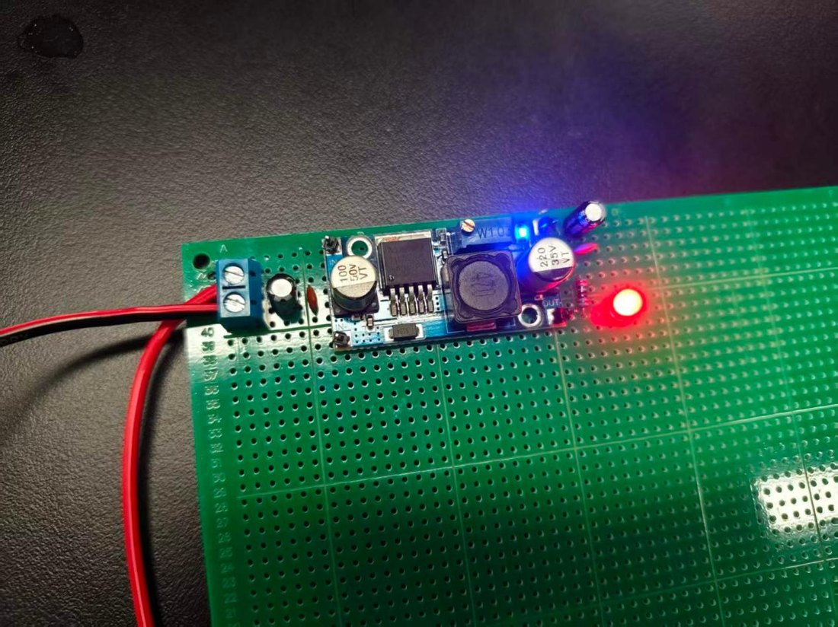
Figure 20. The driver and indicator circuit during soldering
9 October — Test-ready parts designed
Emitter_Plug, Receiver_Plug and Heater_Plug were completed. They are not ad-hoc parts for a single test but purpose-designed structures: the emitter holds the 485 nm LED, the focusing lens and the excitation filter; the receiver holds the emission filter, the focusing lens and the BPW34 photodiode; the heater plug routes the heating-film leads and the PT100 into the block while keeping light out and assembly simple. Output files: Emitter_Plug, Receiver_Plug, Heater_Plug.
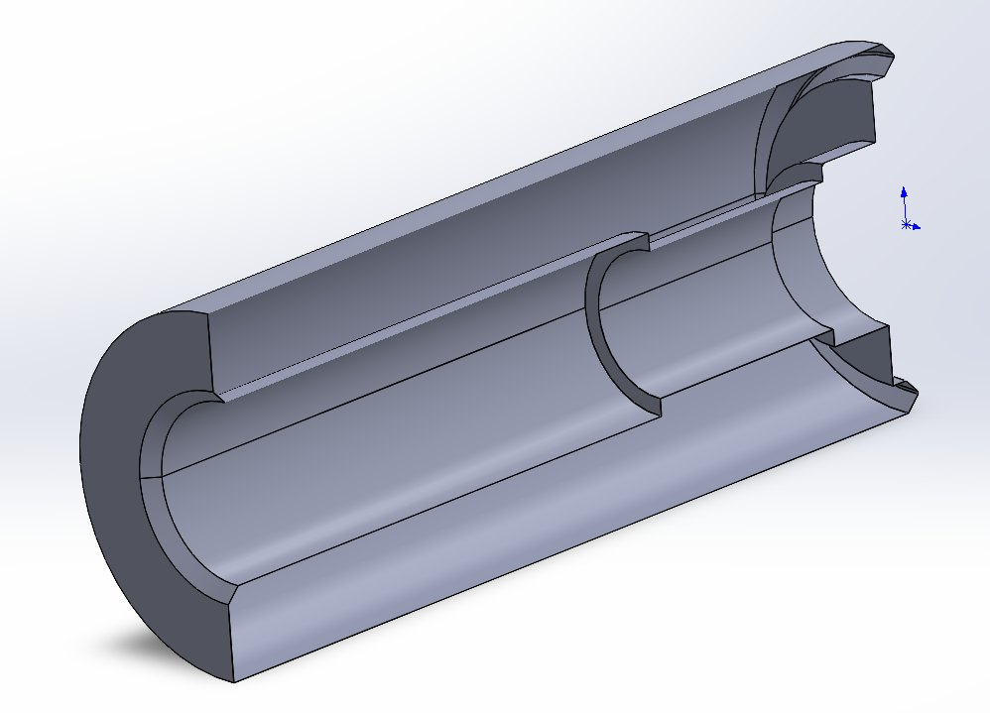
Figure 21. 3D model of Emitter_Plug
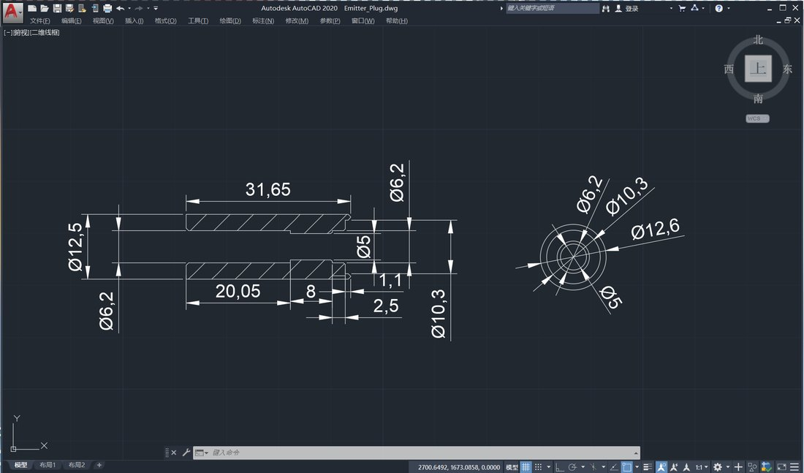
Figure 22. Dimensioned drawing of Emitter_Plug
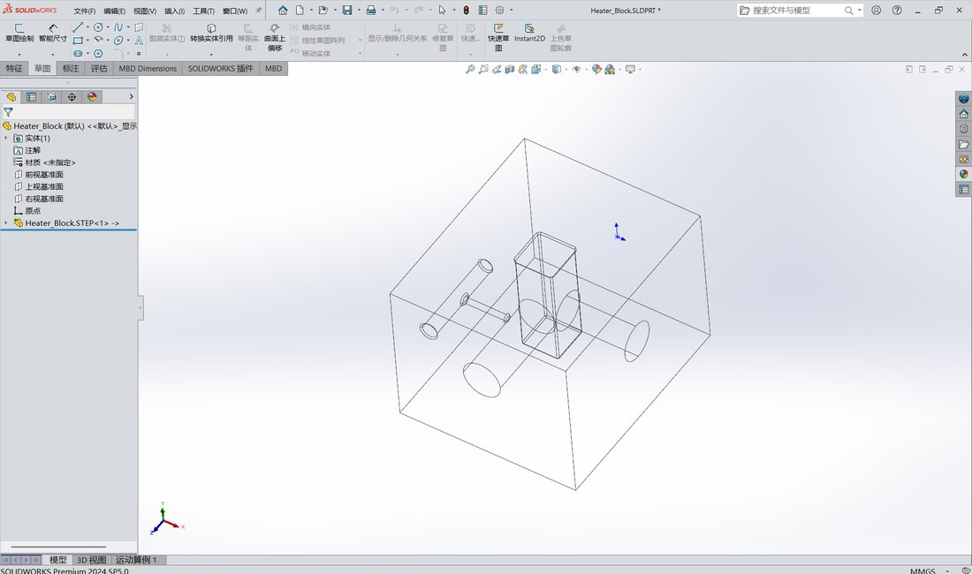
Figure 23. 3D model of Heater_Plug
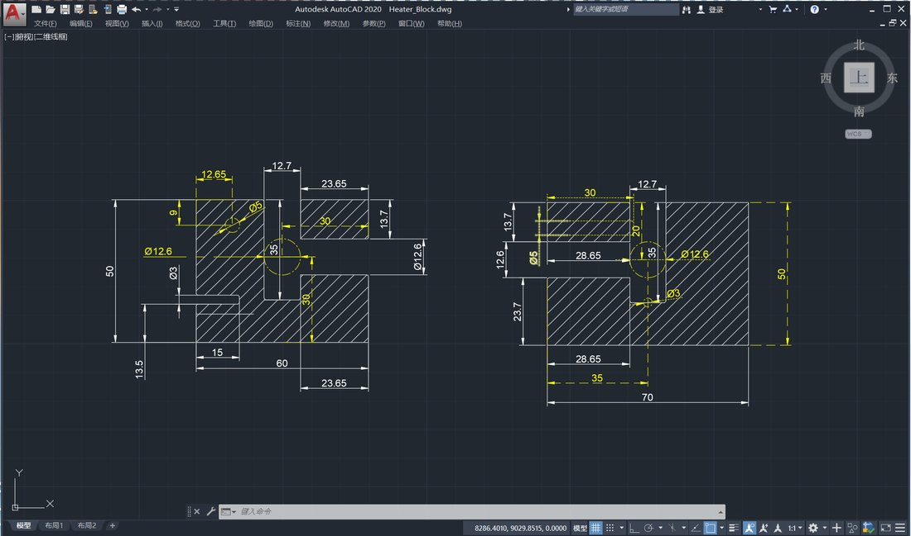
Figure 24. Dimensioned drawing of Heater_Plug
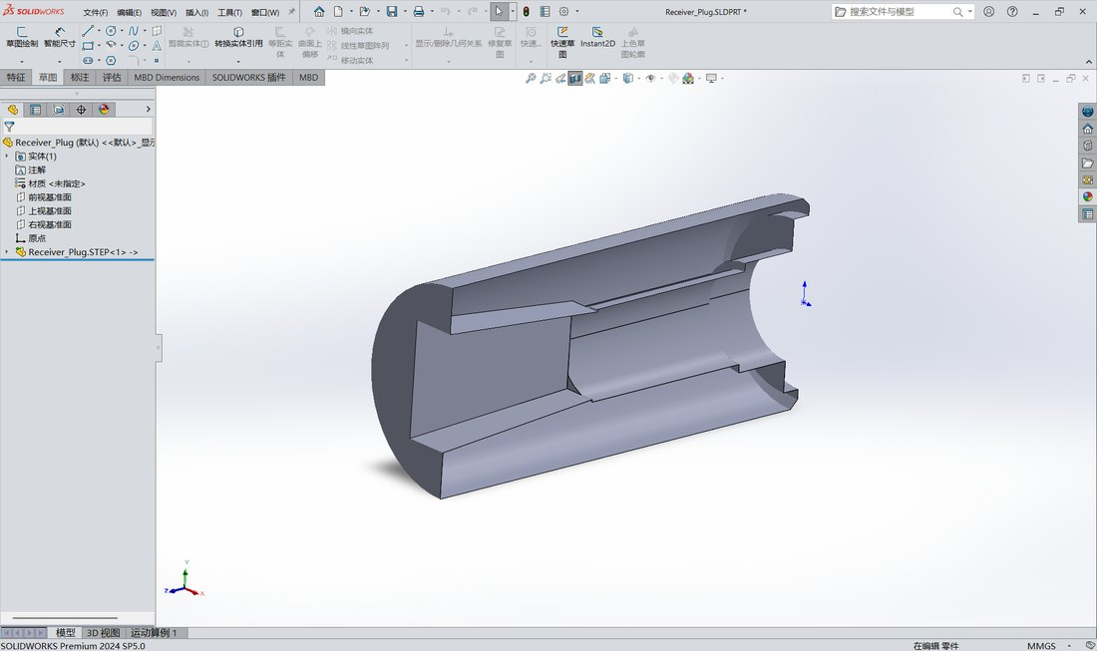
Figure 25. 3D model of Receiver_Plug
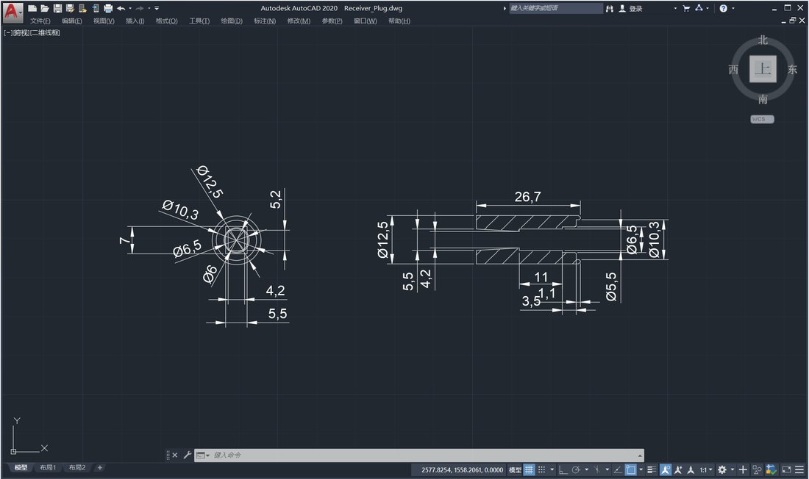
Figure 26. Dimensioned drawing of Receiver_Plug
11 October — Circuit rewired
The wiring was rearranged, separating power runs from signal runs for component safety and signal quality, and preparation for the first integrated test continued. As of 14 October, wiring and debugging are still ongoing.
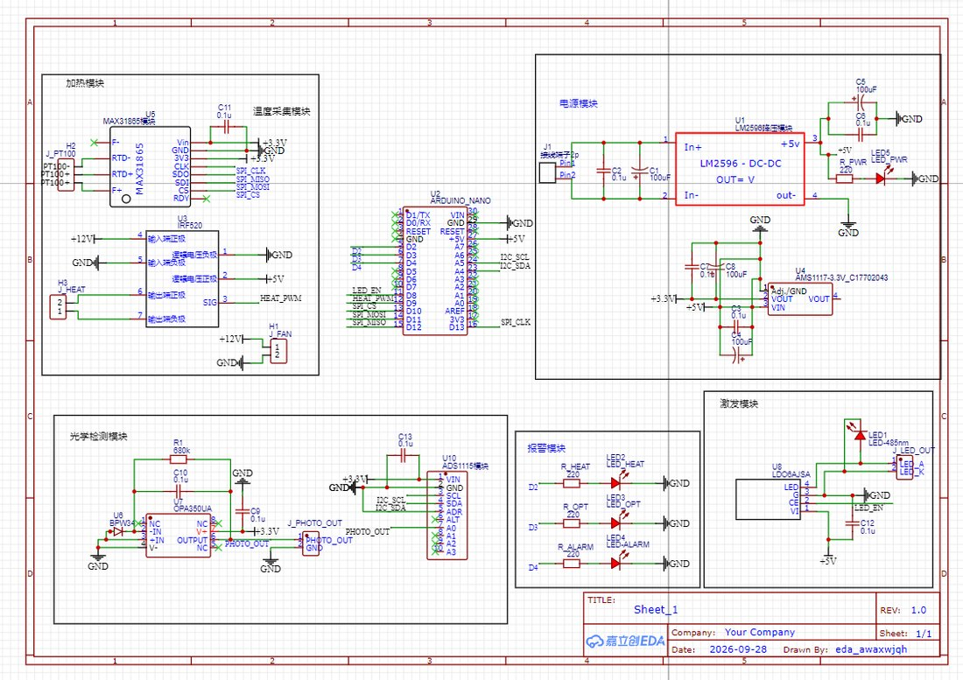
Figure 27. The circuit after rewiring
As of 14 October the circuit is still being wired and debugged, and CNC-machined test parts have been commissioned. Figures 1–27 are the original screenshots and photographs from the log.
6 Optical and Electronic Architecture
6.1 Optical path
485 nm LED → focusing lens → 485 nm narrow-band filter → vessel (cuvette / collection cup) → 528 nm narrow-band filter → focusing lens → BPW34 photodiode → OPA350 transimpedance amplifier → ADS1115 (16-bit, I²C).
6.2 Temperature control
PT100 (3-wire) → MAX31865 (16-bit, SPI) → PID loop on the microcontroller → IRF520 (PWM) → PI heating film, with a KSD9700 (60 °C) in series with the heater as hardware-level protection.
6.3 Power
24 V adapter → LM2596 → 12 V (heating film, fan) and 5 V (logic). Power and signal wiring are routed separately so that switching noise does not couple into the microampere-level photocurrent.
7 Current Specifications
Item | Current specification
Set point | 30 °C
Temperature accuracy | ±0.5 °C (steady state)
Heat-up time | Room temperature to 30 °C in ≤ 5 min
Excitation | 485 ± 5 nm
Emission | 528 ± 10 nm
Optical channel | Single channel; excitation and collection axes at 90°; 8 mm bore
Filters | Ø10 mm narrow-band, 30 nm FWHM, OD3; 485 nm at the emitter, 528 nm at the receiver
Detection | BPW34 silicon PIN photodiode with OPA350 transimpedance amplifier
ADC | ADS1115, 16-bit, 4 differential channels, I²C
Temperature sensing | PT100 (Class A, 3-wire) with MAX31865 (16-bit, SPI)
Heating | PI film 60 × 70 mm, 12 V / 25 W × 2; IRF520 PWM drive
Over-temperature | KSD9700 (60 °C, 10 A) in series plus a 45 °C software threshold
Vessel | Test stage: standard 10 mm path-length cuvette; project stage: in-house collection cup
Power | DC 24 V / 2 A, stepped down internally to 12 V / 5 V
The table above lists only the key figures. The complete module-level specification — structural, thermal, optical, signal-acquisition, power, safety and biosafety parameters, together with the corresponding test methods, inspection rules and packaging and storage requirements — is collected in a separate specification document, attached after this section.
This is where the module technical requirements document should be inserted.
8 Bill of Materials
Category | Items | Main components
Structure and printing | 1 | PLA filament (white / black)
Temperature control | 7 | PI heating film, PT100 + MAX31865, KSD9700, IRF520, thermal pad, 40 mm fan, aluminium heat sink
Optics | 7 | 485 nm LED, constant-current driver, BPW34, Ø10 mm narrow-band filters (485 / 528 nm), OPA350, focusing lenses, black heat-shrink tubing
Electronics and signal | 4 | Arduino Nano, ADS1115, SOT89 / SOT223 adapter boards
Power and wiring | 9 | 24 V adapter, LM2596, perfboard, jumpers, electrolytic capacitors, resistor kit, indicator LEDs, KF301 terminals, 30 AWG silicone wire
Tools and consumables | 8 | Thermal adhesive, PI thermal tape, 22 AWG silicone wire, desoldering wick, multimeter, 936 soldering station, hot glue gun, solder
The table above summarises the main components of this hardware by functional category. The complete itemised purchase list — name, specification, quantity, unit price, purpose and purchase link for every item, together with category totals — is provided as a separate spreadsheet, attached after this section.
This is where the final purchase list should be inserted.
9 The Complete Instrument and the Overall Plan
Beyond the modules, we also have a full set of technical requirements for the instrument as a whole: a wet-wall cyclone bioaerosol sampling and optical detection instrument that integrates cyclone sampling, a COC collection cell, temperature control, optical detection, data display and host software in a single machine. This is not a superseded earlier concept — it is our picture of the final product, and it is the basis on which the current modules were designed: their interfaces, dimensions and specifications were all set to meet the requirements of the complete instrument.
The overall plan does include a display and host software. An instrument sitting in a classroom or a hospital ward has to show temperature and fluorescence readings without a computer attached to it, and it has to be able to export continuous data for trend analysis. Our order of work is to build the core functions first — temperature control, optics and the signal chain — and to make those three stable, repeatable and reproducible before layering display and host software on top. The current hardware revision covers the core functions, with the module interfaces already reserved for that later expansion.
Item | Complete instrument
Format | Wet-wall cyclone bioaerosol sampling + liquid collection + yeast whole-cell detection + optical readout, integrated in one unit
Sampling flow | 100–300 L/min (adjustable)
Sampling time | 15–30 min for viral aerosols
Working volume | 20 mL liquid medium (with yeast)
Collection cell | Custom medical-grade optical COC injection moulding, M28×1.5-6g thread, Ø32 / Ø36 mm cylindrical section, 12° half cone angle, two orthogonal Ø10 mm optical windows at 90°, 2 mm wall
Temperature control | PI heating film 100 × 100 mm, 24 V / 50–100 W; CNC aluminium block (6061 / 7075), 4–9 bores Ø22–25 mm, 30 mm deep; PT100 + MAX31865; ±0.5 °C
Optics | 485 nm excitation, 480/30 and 530/20 filters, BPW34 / SFH203 detection, OPA350 transimpedance stage, ADS1115 acquisition
Size and weight | approx. 300 × 250 × 200 mm, ≤ 5 kg
Power | AC 220 V ± 10%, 50 Hz; or DC 24 V / 5 A
Several decisions from the complete instrument have already been carried directly into the current modules: the cyclone liquid-sampling route, the 90° orthogonal arrangement of the COC optical windows, the PI film + PT100 + MAX31865 combination for temperature control, the 485 / 528 nm filter pair, the BPW34 + OPA350 + ADS1115 detection chain, and the KSD9700 hardware over-temperature protection.
The table above is only a summary of the key figures of the complete instrument. The full equipment specification is a separate document with eight parts — scope, normative references, terms and definitions, technical requirements, test methods, inspection rules, marking and packaging, and notes — together with eight parameter tables.
This is where the complete instrument specification should be inserted.
10 Test Plan
CNC-machined test parts have been commissioned to replace the printed parts and to verify the parallelism and surface quality of the optical windows; the printed parts continue to be used for assembly and plug-interface checks.
Test | Method and criterion
Fit and assembly | Insert / remove each plug 20 times and reassemble the vessel 5 times; check for play and reading drift (drift ≤ 5%)
Temperature accuracy | Set 30 °C; after 20 min stabilisation measure inside the vessel bore with a calibrated thermometer; deviation ≤ ±0.5 °C
Temperature uniformity | Measure at several heights in the vessel bore; difference ≤ 0.5 °C
Over-temperature protection | Break the temperature feedback so heating runs continuously; confirm the KSD9700 cuts the heater circuit before 60 °C
Light-tightness and dark noise | With the excitation source off under room lighting, acquire for 5 min; drift ≤ 1% of full scale
Optical alignment | Insert and remove the plugs 10 times; spot position repeatability on a paper screen ≤ 0.5 mm
Background and fluorescence response | Compare against blank medium; then compare HA-induced and uninduced yeast samples on the 528 nm channel
Repeatability | Measure the same positive sample ≥ 5 times; RSD ≤ 5% (target, to be confirmed by data)
Co-culture compatibility | Aerate and stir the medium in the cup for 30 min; observe foaming, evaporation and yeast viability, and record readout stability
11 Challenges and Lessons
- Print settings and supports: the failed first print showed that print orientation and support placement must be considered at the design stage — long slender cones string badly.
- Channel size: only after widening the optical channel to 8 mm did it become usable. That is the lower bound that still fits Ø10 mm filters, a lens assembly and alignment margin.
- Detachable modules: making the optics plug-in moves the alignment problem from the assembled instrument into the plug itself. Once the plug is fixed, assembling the instrument becomes a repeatable insertion.
- Co-culture cuts both ways: putting the yeast directly into the sampling liquid overlaps sampling time with expression time, but it also brings foaming, evaporation, contamination and a moving liquid surface into the optical path. Each of these has to be quantified during testing.
- Enrichment is the bottleneck: conversations with experts made clear that target virus concentrations in air are extremely low, and that enrichment efficiency, more than detection sensitivity, limits the whole system. This is why we kept the cyclone sampling and liquid-enrichment route.
- Validate before integrating: running temperature control and optics with a standard cuvette first keeps the uncertainty of a custom vessel out of optical debugging.
12 Future Work
- Integrate the cyclone sampling front end with the heated block so that sampling, enrichment and detection close the loop in one cup, and quantify the enrichment efficiency.
- Verify yeast viability and readout stability under co-culture, and fix the sampling flow rate, sampling duration and settling time.
- Replace the PLA parts with the CNC parts once they arrive, and re-check window parallelism, surface quality and light-tightness.
- Complete the first integrated test to establish detection limit, repeatability and response time.
- Once the core functions are validated, add the data display and host software in line with the overall plan, and complete the full instrument specification.

